Experience the Magic of pure flight    www.torontosoaring.ca | 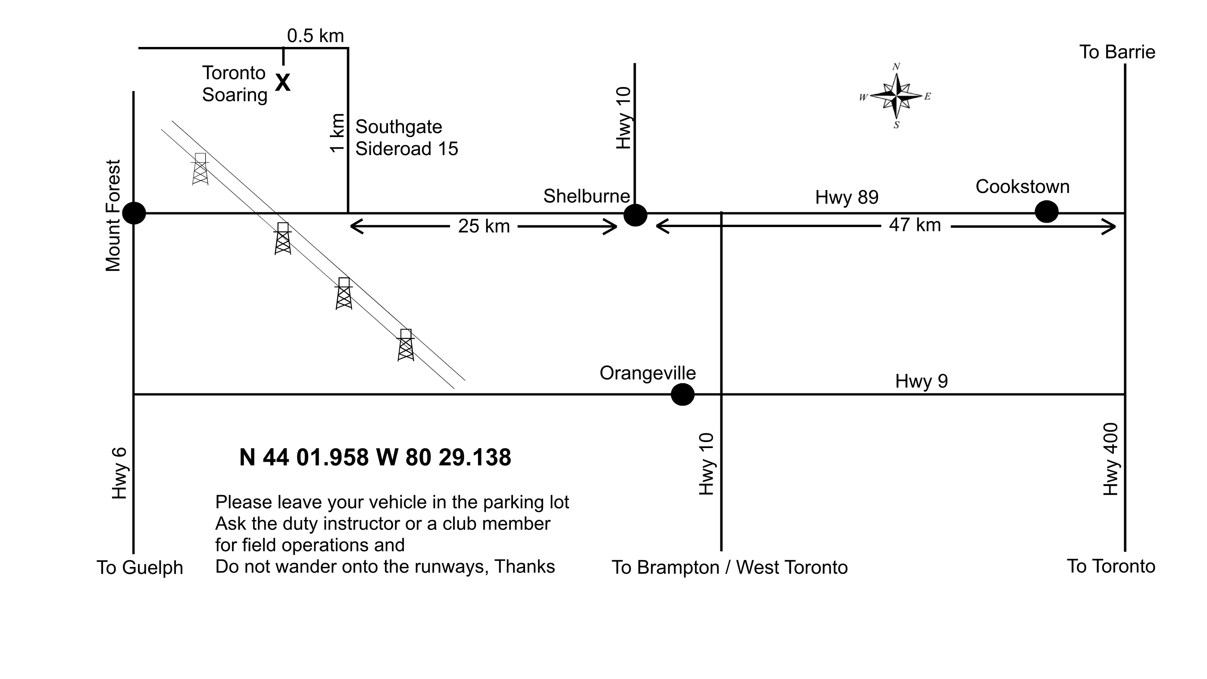
Experience the Magic of pure flight

www.torontosoaring.ca

Experience the Magic of pure flight

www.torontosoaring.ca

Experience the Magic of pure flight

www.torontosoaring.ca

Experience the Magic of pure flight

www.torontosoaring.ca

